Start using Tekla Structures 2022
The purpose of this document is to ensure that you as a Tekla Structures user can quickly and easily switch to Tekla Structures 2022.
When you switch to Tekla Structures 2022 as a Tekla Structures user, you can use the settings and files that you have customized in a previous Tekla Structures version. Tekla Structures will not copy them automatically, you have to do it manually. That’s the reason for logbook.
We recommend that you take a look at the following ponts of attention regarding changes/customizations/settings you made in your previous Tekla Structures version. Compare them to your situation and, if necessary, take the steps that apply to you. This allows you to continue working with the new version quick and easily.
It is recommended to document you changes in this Word document as a logbook, possibly complemented with your personal points of attention to make sure that you always know what your changes are.
Points of attention | Checked by
- Installing_Tekla_Structures
- License Administration Tool
- License Borrow Tool
- Tekla_Structures_license
- Personal_settings_and_extensions
- New_TS_folder
- Copy_files_to_the_TS_folder_and_check_the_files
- Backup_various_folders
- Copying_macros
- Configuration_file_for_unfoldings_(n.a._for_model_templates)
- Copying_customized_advanced_options
- Copying_custom_components
- Copying_and_updating_model_templates
- Merging_catalogs
- Copying_customized_or_added_user-defined_attributes
- Copying_and/or_comparing_the_customized_ribbon
- Copying_customized_shortcuts
- Property_pane_layout
- Part_settings
- Component_settings
- Organizer_settings
- Copying_standard_Project_properties
- Copying_standard_parts
- Copying_customized_Applications_and_components_catalog

In the list above you will see an addition for some points of attention (not applicable for model templates). This indicates that the relevant settings can be saved in model templates. See point 13 for more information about model templates.

In addition, this document regularly refers to certain topics via links. If this link does not work immediately (because you have to log in to Tekla User Assistance), you can right-click on the link and select the Copy hyperlink option. Then paste the link into your internet browser and click Enter, the article will open.
- Installing Tekla Structures
Make sure that the Tekla Structures version is installed in the correct folder:
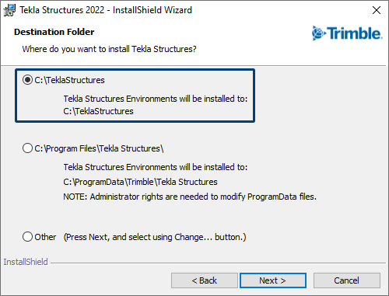
For more information about installing Tekla Structures 2022, click here.

Back_to_Points_of_attention
- License Administration Tool
Check if the license server needs to be updated, you can find this in the article about installing Tekla Structures in the TUA. For more information about the license server version to use, click here.

Back_to_Points_of_attention
- License Borrow Tool
When you use the License Borrow Tool to borrow licenses, feel free to check whether the version of the tool is still up to date. For the most recent License Borrow Tool, click here.

Back_to_Points_of_attention
- Tekla Structures license
Make sure you have an appropriate license for the relevant Tekla Structures version. Licenses are sent proactively by Construsoft; if you do not yet have the correct license, you can request it via administratie@construsoft.com
For more information about activating licenses, click here.
For information on backing up activated licenses, click here.

Back_to_Points_of_attention
- Personal settings and extensions
You can use the Migration wizard to copy various personal settings and extensions to the new Tekla Structures version. The Migration wizard opens automatically the first time you start the new Tekla Structures version. If you want to copy the settings later, you can start the Migration Wizard manually by double-clicking the file MigrationWizard.exe in the folder ..:\TeklaStructures\2022.0\bin\applications\Tekla\Migrations.
You can also migrate extensions that you have added via Tekla Warehouse to your earlier Tekla Structures version to the new Tekla Structures version via Applications and component catalog > Access advanced features > Manage extensions > Migrate extensions. Next follow the steps in the Wizard.

Tip: It might happen that the content of the extensions you use changed and is refreshed/updated in Tekla Warehouse. It is therefore preferable to set up so-called alerts in Tekla Warehouse to be informed about changes to the content.
Back_to_Points_of_attention
- New TS folder
Per Tekla Structures version you use a TS folder. This folder can be stored locally, on a server, or in a cloud service:
Local | 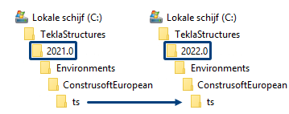
Server | 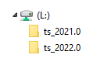
Cloud service

Local: The local TS folder is created automatically when you install Tekla Structures. You can copy the files from the TS folder of your previous version to the TS folder of your new version.
Server: When using a TS folder on a server, create a new TS folder on this server for the new Tekla Structures version. Next change the reference to the TS folder in Tekla Structures. For more information on this, click here.
Cloud service: Using a TS folder from a cloud service ensures that all Tekla Structures users always use the same correct settings and that updates are automatically shared with everyone. For more information on this, click here. For an (English) instructional video, click here.
Copy the files from the TS folder from your earlier Tekla Structures version to the new TS folder, see also the next point of attention.
If you store images and symbols (which appear in templates in drawings) in the new TS folder on the server, you must also add the new location of the TS folder to a line in the files user.ini and tpled.ini so that they are displayed. For more detailed information on this, click here.
Note: Never use one TS folder that refers to all Tekla Structures versions but create a TS folder per version. For detailed information about the TS map, click here.

Back_to_Points_of_attention
- Copying files to the TS folder and checking the files
You can save your personal files in the TS folder so that they are available in all models. When you copy files from a TS folder of an earlier Tekla Structures version to the new TS folder, it is a good idea to check what you are actually copying, especially if the files are already copied several versions. Think, for example, of files that you use to create NC files (possibly with pop-marks). You may need to update these files for the new version because settings can differ per version, for example because new functionalities or user-defined attributes that have been added. Also sort the files by date to see how old the settings are.
Since Tekla Structures 2019i, you can also use subfolders in the TS folder and store your own files in these subfolders. This allows you to organize the settings in a structured way and therefore manage them more easily. Click here for detailed information.
Since Tekla Structures 2019i, you can also use subfolders in the TS folder and store your personal files in these subfolders. This allows you to organize the settings in a structured way and therefore manage them more easily. Click here for detailed information.

Back_to_Points_of_attention
- Backup various folders
By using a new TS folder, either locally or on a server, it is important to check whether this new TS folder is already being backed up. It is advisable to also include other folders in which you copy personal files in the backup. (For files in a cloud service this is not necessary because these files are always backed up).
For example, consider the folder where you store your custom components (see point 12), the folder where you store your model templates (see point 13) or a possible new location for your models.

Back_to_Points_of_attention
- Copying macros
By default, Tekla Structures includes a large number of so-called macros (scripts), such as macro Write Numbering Results to UDA (ML006) to change the numbering of parts.
If you have recorded one or more macros or if you have manually created macro files, it is good to know where they are stored.
By default, they are stored in the global folder ..:\Environments\common\macros\modeling or ..:\Environments\common\macros\drawings depending on the mode (modeling or drawing) you were working in when you created the macro.
You may have added your personal local folder to the existing default location (use a semicolon (;) as a separator between the two locations) by defining the location of this folder in the advanced option XS_MACRO_DIRECTORY in File > Settings > Advanced options > File Locations.
For general information and detailed information about the location of macros, click here.

Back_to_Points_of_attention
- Configuration file for unfoldings (n.a. for model templates)
Configuration file unfold_corner_ratios.inp contains settings with which can affect unfoldings. The file is saved in the folder .\ ConstrusoftEuropean\General\ModelSettings by default in Tekla Structures but can also be stored in the model folder (in the model template) or in the TS folder.
The parameters in this file define the position of the neutral line when unfolding a profile, for example when displaying unfolded plates in single-part drawings.
For detailed information about unfolding plates and profiles, click here.

Back_to_Points_of_attention
- Copying customized advanced options
Tekla Structures includes different types of advanced options that you can customize. The available advanced option types are:
- Model-/drawing specific (MODEL/DRAWINGS). This type of advanced option can be used in model templates.
- User specific (USER).
- System specific (SYSTEM).
- Role specific (SYSTEM(ROLE)).
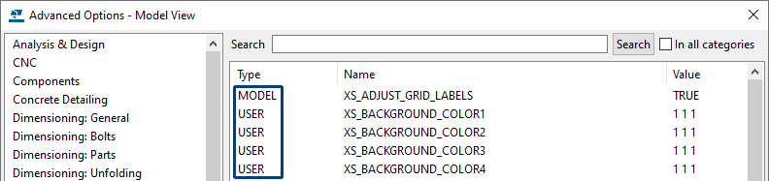
For example, using advanced options you can set the reference to the TS folder or the background color in model views and drawings. When you customize an advanced option, the type of advanced option determines the level at which Tekla Structures makes the change.
Examples
Advanced options XS_BACKGROUND_COLOR1 till XS_BACKGROUND_COLOR4 to control the color of each corner separately in a model view.
Advanced option XS_BLACK_DRAWING_BACKGROUND to set the background color in drawings.
Advanced option XS_USE_ASSEMBLY_NUMBER_FOR to set the assembly/cast unit number to be also the main part number for the corresponding assembly/cast unit. Several options for the advanced option available.
Advanced option XS_DSTV_NUMBER_OF_PARTS_BY_SELECTION to add the number of parts in the header of an NC file by the parts that have been selected in the model.

For detailed information about the different types of advanced options and how to customize advanced options, click here.

Back_to_Points_of_attention
- Copying custom components (n.a. for model templates)
To copy custom components from an earlier Tekla Structures version, you need to know where the so-called *.uel files are stored. The location of these files is defined via the advanced option XS_UEL_IMPORT_FOLDER and is stored in the "role" file you are working with in the folder ..:\TeklaStructures\<version>\Environments\ConstrusoftEuropean, for example the file role_Steel_Detailer.ini.
Here you can save your personal custom components (*.uel files) so that they are automatically read into Tekla Structures.
For more information about copying custom components, click here.

Back_to_Points_of_attention
- Copying and updating model templates
You can define model templates to use as a basis when you create new models. They contain predefined settings: for example, you can create a model template per client in which specific settings are stored, such as a company logo in drawings, customized databases such as a profile catalog or a bolt catalog or customized component settings.
The main advantage of using model templates is that, when you have created a model based on a model template and reopen it later, all settings are still available so that the model is displayed correctly. After all, there are no missing profiles, bolts, templates, etc. because this is all stored in the model folder.
In case you have created your own model templates, update these model templates to use them smoothly in the new Tekla Structures version.
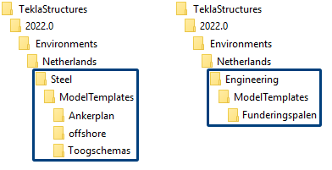
For detailed information about updating model templates, click here.

Back_to_Points_of_attention
- Merging catalogs
You may have modified catalogs such as the profile catalog (profdb.bin), material catalog (matdb.bin), bolt catalog (screwdb.bin) and/or the bolt assembly catalog (assdb.bin) in your earlier Tekla Structures version.
You can copy these custom catalogs from your previous one to your new Tekla Structures version, but you can also merge the previous customizations you made in the catalogs with the new catalogs in the new Tekla Structures version.
For information about merging the profile catalog, click here.
For information about merging the material catalog, click here.
For information about merging the bolt and bolt assembly catalog, click here.

Back_to_Points_of_attention
- Copying customized or added user-defined attributes
You can use the file objects.inp to add user fields that appear in the existing tabs in the dialog boxes. You save the file objects.inp in the TS folder, the model folder or in the model template.
For more information about adding user-defined attributes, click here.

Back_to_Points_of_attention
- Copying and/or comparing the customized ribbon
You can copy the customized ribbon to the new Tekla Structures version (but also from one PC to another PC). These settings are saved per Tekla Structures version in the Windows user profile.
You can also choose to first compare the customized ribbon with the new "default" ribbon in Tekla Structures 2022.
For more information about copying or comparing the customized ribbon, click here (Chapter Localization: Update personal settings/files > The customized ribbon and shortcuts).

Back_to_Points_of_attention
- Copying customized shortcuts
You can copy customized shortcuts from the old to the new Tekla Structures version (as well as from one PC to another). These settings are saved per Tekla Structures version in the Windows user profile.
For more information about copying customized shortcuts, click here (Chapter Localization: Update personal settings/files > The customized ribbon and shortcuts).

Back_to_Points_of_attention
- Property pane layout
In Tekla Structures, many objects such as columns and beams include their own property pane layout. Due to improvements in the IFC export, the settings of the IFC entity are now moved from the user-defined attributes dialog box for model objects (on both part and assembly level) to the IFC export section in the property pane for model objects and are now accessed more easily.
In case you have customized the content of the property panes in earlier Tekla Structures versions, and you copy these settings to Tekla Structures 2022, the IFC related fields mentioned above are missing.
For more information about copying customized shortcuts, click here (Chapter Localization: Update personal settings/files > The customized property pane layout).

Back_to_Points_of_attention
- Part settings
In Tekla Structures you have the possibility to create and save settings for all parts (columns, beams, contour plates, concrete walls, reinforcement, etc.) in the property panes. Due to improvements in the IFC export in order to better comply with agreements regarding the exchange of information, the name of the IFC entity attribute has been changed.
To make sure that your self-saved settings are suitable for correct export to IFC4 in Tekla Structures 2022, you must again set the correct value fields for the IFC export.
For more information about part settings, click here (Chapter Localization: Update personal settings/files > Part settings).

Back_to_Points_of_attention
- Component settings
In Tekla Structures you have the possibility to create and save settings for all components in the properties dialog boxes. Due to improvements in the IFC export in order to better comply with agreements regarding the exchange of information, the name of the IFC entity attribute has been changed.
To make sure that your self-saved settings are suitable for correct export to IFC4 in Tekla Structures 2022, you must again set the correct value fields for the IFC export.
For more information about component settings, click here (Chapter Localization: Update personal settings/files > Component settings).

Back_to_Points_of_attention
- Organizer settings
In Organizer in Tekla Structures you have can create personal categories and/or templates. Due to improvements in the IFC export in order to better comply with agreements regarding the exchange of information, the name of the IFC entity attribute has been changed. As a result, a number of templates and categories have been adjusted.
For more information about Organizer settings, click here (Chapter Localization: Update personal settings/files > Organizer settings).

Back_to_Points_of_attention
- Copying standard Project properties (n.a. for model templates)
In Tekla Structures, you can set the fields in the Project properties and make them available as a new default. You may have modified these files (standard.prf and standard.prf.more) in your earlier Tekla Structures version and saved them in the TS folder. You can copy these files to the TS folder of the new version.
For more information about editing project properties, click here.

Back_to_Points_of_attention
- Copying standard parts
In Tekla Structures you can use standard parts (for example, base plates, purlin lips). This gives these parts the same number for each project. This is especially useful if you want to stock up on certain parts. When you want to include standard parts to the new Tekla Structures version, the advanced option XS_STD_PART_MODEL must be set, and the relevant model must be copied with the standard parts.
For more information about creating a standard part model, click here.

Back_to_Points_of_attention
- Copying customized Applications and components catalog
When you have customizations in the Applications and component catalog, you can copy these to the new Tekla Structures version. The customizations are saved in the file ComponentCatalog_<username>.xml.
Before making changes, you can set the Applications and components catalog to save the changes in the TS folder. To do this, in the Applications & components catalog, go to Access advanced features > Catalog management > Edit mode and select the folder where you want to save the customizations.
For more information about copying customized Applications and component catalog, click here (Chapter Localization: Update personal settings/files > Customized Applications and component catalog).
For more information, click here and here.

Back_to_Points_of_attention
Notes

